

<Name of Software Application>

CS 465 Project Software Design Document
Version 1.0

Table of Contents

CS 465 Project Software Design Document 1
Table of Contents 2
Document Revision History 2
Instructions 2
Executive Summary 3
Design Constraints 3
System Architecture View 3
Component Diagram 3
Sequence Diagram 4
Class Diagram 4
API Endpoints 4
The User Interface 4

Document Revision History

Version | Date | Author | Comments
1.0 | <mm/dd/yy> | <Your Name> | <Brief description of changes in this revision>

Instructions

Fill in all bracketed information on page one (the cover page), in the Document Revision History table, and below each header. Under each header, remove the bracketed prompt and write your own paragraph response covering the indicated information.

Executive Summary

The architecture of the Travlr Getaways application is designed around the MEAN stack, which consists of MongoDB, Express.js, Angular, and Node.js. The idea is fairly simple: information about trips is stored in a database, a server retrieves and updates that information, and users interact with it through web applications.

On the customer-facing side, visitors can browse available travel packages and view information about destinations offered by Travlr Getaways. When a user requests information, the application communicates with the server, which retrieves the appropriate data from the MongoDB database and returns it to the user.

The administrator side of the application is built as a single-page application (SPA) using Angular. Instead of loading a new page each time an administrator performs an action, the SPA updates information dynamically within the browser. This allows administrators to efficiently add, edit, and remove trip information while communicating with the same backend services used by the customer-facing website. Together, MongoDB stores the application data, Node.js and Express.js provide the server and API functionality, and Angular delivers an interactive administrative interface. This architecture allows both customer and administrative users to access the same data while serving different business needs.

Design Constraints

Every engineering project begins with a set of rules that cannot be ignored. These rules are often called constraints because they define what can and cannot be done during development. The Travlr Getaways application has several important constraints that shape how the system is designed.

The first constraint is the requirement to use the MEAN stack, which includes MongoDB, Express.js, Angular, and Node.js. This means the application must be built using these technologies even if other frameworks or databases could accomplish the same task. In practice, this affects how information is stored, how the server operates, and how users interact with the application.

Another constraint is the need to support two different types of users. Customers need a website where they can browse trips and view travel information, while administrators need a single-page application that allows them to manage that information. Although both sides of the system work with the same data, they have very different jobs. As a result, the application must provide two different user experiences while keeping the underlying information synchronized.

The database itself introduces another constraint. All trip information must be stored and managed in MongoDB. Because MongoDB is a document database rather than a traditional relational database, the data must be organized in a way that works efficiently within that structure. The server must also provide a reliable method for retrieving and updating information stored in the database.
Security creates another important limitation. Customers should be able to view trip information, but only authorized administrators should be able to create, modify, or delete records. This requires authentication and access controls to ensure that administrative functions remain protected from unauthorized users.

Finally, the application must be designed with future growth in mind. New trips, destinations, and features will likely be added over time. If the system is not organized carefully, even small changes can become difficult and expensive to implement. For this reason, the application must use modular components and a flexible database structure that can adapt as requirements evolve.

These constraints influence nearly every development decision. They determine which technologies are used, how information moves through the system, how users interact with the application, and how the application can grow in the future. While constraints limit certain design choices, they also provide a framework that helps ensure the final product remains reliable, maintainable, and capable of meeting the needs of Travlr Getaways.

System Architecture View

Component Diagram

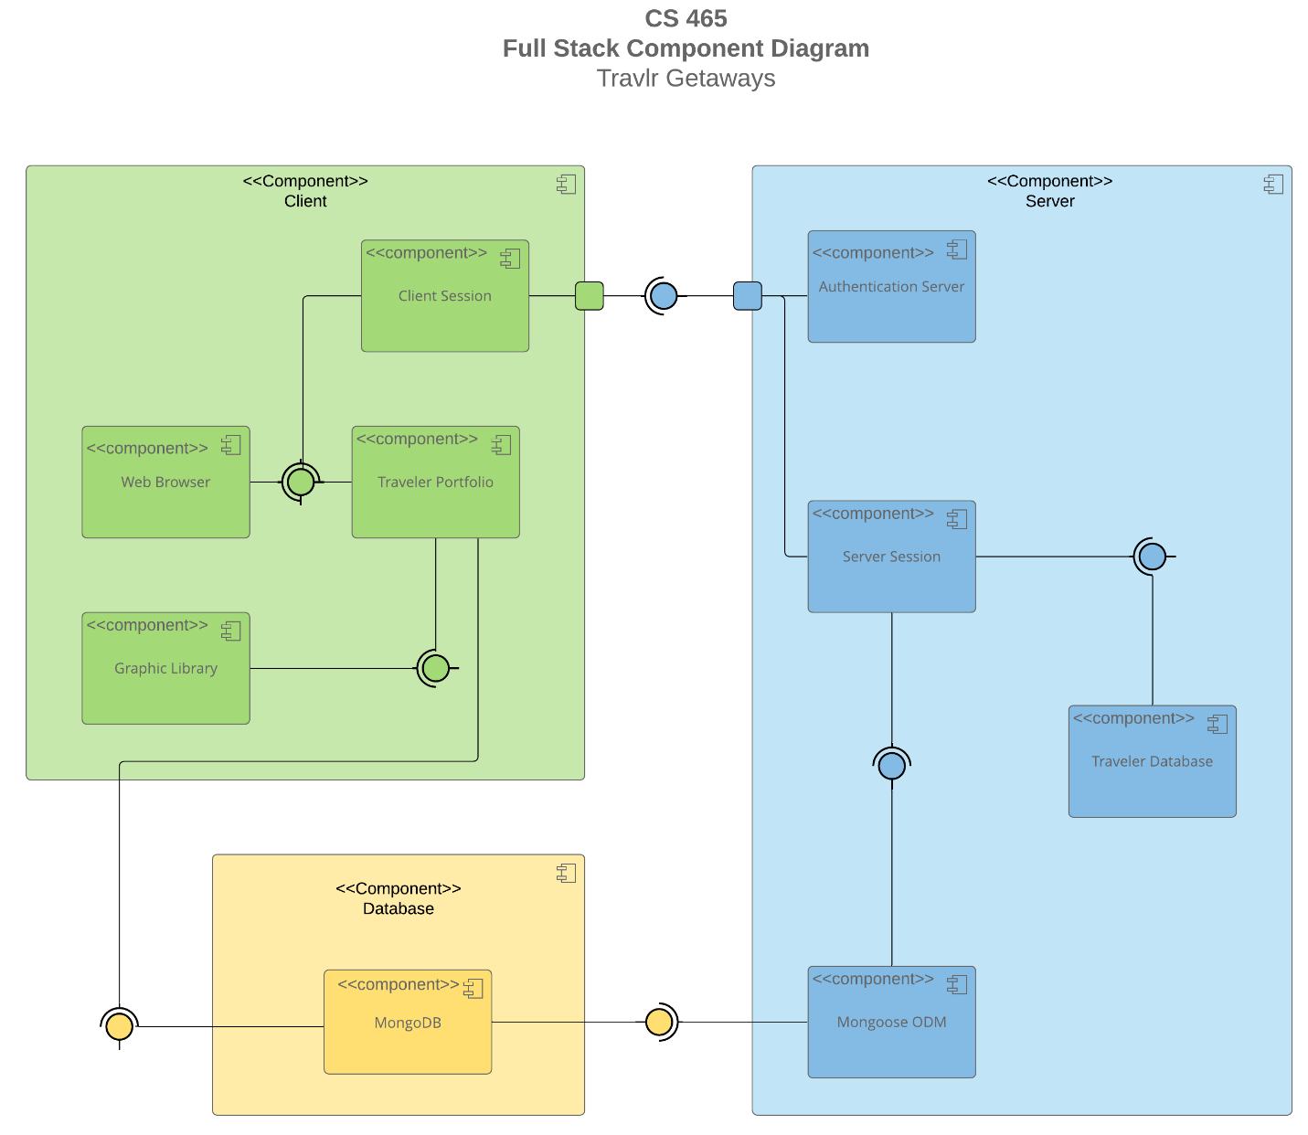

A text version of the component diagram is available: CS 465 Full Stack Component Diagram Text Version.

<Describe the overall system architecture of the web application by referring to the component diagram above. Identify the significant components that will be used and their relationships to one another.>

The component diagram shows the web application as three connected parts: the client, the server, and the database. Thinking about it this way makes the system easier to understand because each part has a specific job.

The client is what the user sees and interacts with. Through a web browser, users can access the Traveler Portfolio and view information about available trips. The client session keeps track of the user's interaction with the application, while the graphic library helps present information in a way that is useful and visually appealing.

The server sits between the user and the database. Its job is to receive requests, determine what information is needed, and send the appropriate response back to the client. The Authentication Server helps verify user access, while the Server Session manages communication and processing. In many ways, the server acts like a translator, taking requests from users and turning them into actions the database can understand.

The database is where the application's information is stored. MongoDB holds the travel data that powers the application. Between the server and MongoDB is Mongoose ODM, which helps the application work with database records more naturally without having to interact directly with the database structure.

Together, these components create a layered architecture in which each part performs a specific function. The client focuses on user interaction, the server handles processing and communication, and the database stores information. By separating responsibilities in this way, the application becomes easier to maintain, expand, and manage as the needs of Travlr Getaways grow over time.

Sequence Diagram

<Describe the flow of logic in the web application based on the sequence diagram. Be sure to describe the interactions between the layers, or tiers, of the full stack application. It will be helpful to include significant processes such as Sign In, Trips, and Admin interactions when referring to the sequence diagram.>

Class Diagram
<Describe the JavaScript classes of the web application based on the class diagram.>

API Endpoints

<Exposing RESTful endpoints is a design approach to enable an application to participate in a larger ecosystem. Document each endpoint in the table below, including the HTTP method, purpose, URL, and notes.>

Method | Purpose | URL | Notes
GET | Retrieve all trips | /api/trips | Returns all trip records from MongoDB
GET | Retrieve a single trip | /api/trips/DAWR210315 | Returns one trip identified by tripcode. In our instance it returns Dawson's Reef

The User Interface

<Insert screenshots from the development of the SPA development to show the following: (1) a unique trip, added by you, (2) the Edit screen, and (3) the Update screen.>

<Summarize the Angular project structure and how it compares to the Express project structure. Be sure to describe the rich functionality provided by the SPA compared to a simple web application interaction. Describe the process of testing to make sure the SPA is working with the API to GET and PUT data in the database.>

